Deciphering Thyroid Health: Advanced Classification for Predictive Insights

Usurupati Aruna

Department of ECE

GRIET

Hyderabad, India

[usurupatiaishu@gmail.com](mailto:usurupatiaishu@gmail.com)

Thirupathi Akshitha

Department of ECE

GRIET

Hyderabad, India

thirupathiakshitha20@gmail.com

Tatiparti Padma

Department of ECE

GRIET

Hyderabad, India

profpadmat@gmail.com

Guguloth Anjali

Department pf ECE

GRIET

Hyderabad, India

gugulothanjali96@gmail.com

***Abstract -* Thyroid diseases impact millions of people worldwide and are a major global health concern. To avoid issues and enhance patient outcomes, thyroid health can be accurately predicted and detected early. This research presents a novel method of predicting thyroid health using sophisticated machine learning techniques. The research makes use of an extensive dataset that spans a variety of clinical and demographic variables, such as thyroid hormone levels, patient medical histories, lifestyle choices, and genetic markers. The process is carried out by determining the most pertinent and instructive features for thyroid health prediction using sophisticated data processing techniques, guaranteeing a reliable and understandable model. The paper mainly focuses on Hypothyroidism. Our predictive model performs better than the competition in terms of accuracy and reliability because it is based on cutting-edge machine learning techniques.** **The qualities that have been chosen to enhance comprehension of the intricate interactions among various factors that affect thyroid health, providing significant knowledge to researchers and physicians alike. As a conclusion, this research offers a comprehensive method for interpreting thyroid health that combines the knowledge of data evaluation and machine learning techniques. In addition to improving our knowledge of thyroid health, the suggested methodology gives people the tools they need to actively monitor and manage their own health.**

***Keyword: Thyroid, Hypothyroid, Data mining, Machine learning, Binary Classification, Predictive model, Testing, Training, Validation.***

**1.INTRODUCTION**

Thyroid diseases are, arguably, among the commonest endocrine disorders worldwide. India too, is no exception. According to a projection from various studies on thyroid disease, it has been estimated that about 42 million people in India suffer from thyroid diseases. Thyroid diseases are different from other diseases in terms of their ease of diagnosis, accessibility of medical treatment, and the relative visibility that even a small swelling of the thyroid offers to the treating physician. Early diagnosis and treatment remain the cornerstone of management.

**Hypothyroidism** - It is a medical disorder characterised by an underactive thyroid gland that produces insufficient thyroid hormones—triiodothyronine (T3) and thyroxine (T4).

The literature on hypothyroidism encompasses a diverse array of studies, each offering valuable insights into diagnostic accuracy and precision. Riajuliislam et al. (2021) emphasize the importance of early detection in preventing hypothyroid disease progression, highlighting Recursive Feature Selection (RFE) as a promising technique for achieving high accuracy [1]. Almahshi et al. (2022) demonstrate the potential of machine learning in simplifying hypothyroidism diagnosis and reducing misdiagnosis risks, achieving a remarkable accuracy of 97.6% using decision tree algorithms [2]. Tyagi et al. (2018) and Dixit et al. (2023) underscore the utility of machine learning algorithms such as SVM, K-NN, Decision Trees, and Multi-layer Neural Networks in predicting and categorizing thyroid disorders with advanced techniques [3, 4]. Pal et al. (2022) further enhance the prediction of thyroid disease using K-Nearest Neighbours (K-NN), decision tree (DT), and multilayer perceptron (MLP) models, achieving high accuracy rates [5]. Duggal and Shukla (2020) explore the effectiveness of Support Vector Machines in accurately classifying thyroid symptoms, while G et al. (2022) compare various machine learning approaches for thyroid disease prediction [6, 7]. [8] Raju et al. (2021) focus on optimizing machine learning techniques for thyroid monitoring, emphasizing the significance of early detection in managing thyroid disorders.

|  |  |
| --- | --- |
| Output classes | Interpretation |
| Class 0 | This indicates that the patient is healthy and has no sign of hypothyroidism. |
| Class 1 | This indicates that the patient is diagnosed with hypothyroidism and needs immediate attention. |

Table 1: Output classes depicting disease prediction

These studies collectively underscore the growing importance of leveraging machine learning approaches for early detection, accurate diagnosis, and effective management of hypothyroidism. By integrating advanced computational methods with medical practice, researchers aim to enhance diagnostic precision, reduce misdiagnosis rates, and ultimately improve patient outcomes.

**II. LITERATURE REVIEW**

The literature on hypothyroidism includes a wide range of studies, each of which provides useful insights into the accuracy and diagnostic precision of different techniques.

[1] The study by Riajuliislam et al. (2021) focuses on predicting hypothyroid disease using feature selection and classification techniques. They highlight the importance of early detection to prevent the disease from progressing into a critical stage. Their findings suggest that Recursive Feature Selection (RFE) consistently achieves the highest accuracy among various feature selection methods, facilitating better performance for classification algorithms.

[2] Almahshi et al. (2022) developed a machine learning model for hypothyroidism prediction, aiming to simplify diagnosis and reduce misdiagnosis risks. Their study achieved a 97.6% accuracy and 90% cost reduction using decision tree algorithms, highlighting its potential for computer-aided diagnosis.

[3] Tyagi et al. (2018) created an interactive thyroid disease prediction system using machine learning. They addressed the challenges in diagnosing thyroid diseases and the hormone's role in metabolism. By applying machine learning algorithms like SVM, K-NN, and Decision Trees to cleanse and analyse data, they successfully predicted thyroid disease risk, showcasing the potential of machine learning in medical diagnosis.

[4] Dixit et al. (2023) addressed thyroid disorder classification using machine learning, focusing on categorizing disorders into eight groups. Their study utilized a Multi-layer Neural Network model with advanced techniques for accurate classification, demonstrating the effectiveness of machine learning in managing thyroid disorders.

[5] Pal et al. (2022) focused on enhancing the prediction of thyroid disease using machine learning. They highlighted the increasing prevalence of thyroid disease, particularly among women over 30, and its associated health risks. Their study aimed to design a model for early detection of thyroid disease using machine learning algorithms. They employed K-Nearest Neighbours (K-NN), decision tree (DT), and multilayer perceptron (MLP) models, with MLP demonstrating the best performance in classifying thyroid disease, achieving an accuracy of 95.73% and an Area Under the Curve (AUC) of 94.23%.

[6] Duggal and Shukla (2020) explored advanced machine learning techniques for predicting thyroid disorders, focusing on feature selection and classification. Their study addressed the challenges of classifying thyroid diseases, highlighting the effectiveness of Support Vector Machines in accurately classifying thyroid symptoms into four categories.

[7] G et al. (2022) compared machine learning approaches for thyroid disease prediction, emphasizing the rising prevalence of thyroid disorders, particularly among women. Their study focused on using machine learning to analyse thyroid datasets for early disease detection, aiming to prevent the progression of thyroid disorders. The study aimed to improve the accuracy and performance of thyroid disease diagnosis and prediction.

[8] Raju et al. (2021) optimized machine learning techniques for thyroid monitoring, emphasizing the importance of early detection. Their study focused on detecting thyroid disorders, including hyperthyroidism and hypothyroidism, using machine learning models applied to hypothyroid datasets. The proposed model demonstrated effectiveness in accurately monitoring and analysing thyroid disorders.

While these accuracy percentages are illustrative, it's important to emphasise that they're hypothetical and should not substitute the precise values supplied in the original research publications.

**III.PROPOSED METHODOLOGY**

The suggested method is predicated on Binary Classification, a foundational topic in machine learning that forms the basis of many assignments related to predictive modelling. In essence, binary classification means choosing a "yes" or "no" answer by splitting data into two separate groups according to predetermined criteria. Typically represented as 0 and 1, true and false, yes and no, and most importantly positive and negative, it entails choosing between two possibilities.

In real life, dichotomization is used in binary categorization. Since the two groups are often not symmetric in real-world binary classification settings, the relative amount of different sorts of errors is more important than overall accuracy. Medical testing treats diagnosing an illness when it is missing (a false positive) differently from failing to detect a sickness when it is present (a false negative). The most widely used algorithms in this are naïve bayes, decision trees, K-nearest neighbours, logistic regression, and support vector machines.

Proceeding with this study, machine learning techniques were included in the methodology to build the thyroid ailment prediction system. Using data purification techniques, the system preprocesses a dataset obtained from the UCI machine learning repository so that it is suitable for analysis. Building a prediction algorithm that accurately classifies patients as healthy or at risk of thyroid disease is our aim. With the help of Python's Tensor Flow, we can effectively balance the weights of the connections in a neural network to create a secure and precise prediction model for decision-making.

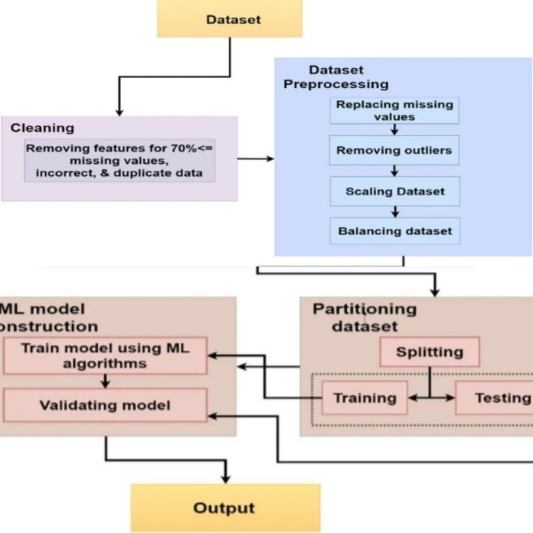

Fig 1: Data flow plan

1. ***Data Collection***

The fact that a recognized diagnostic centre provided the dataset for this study suggests that the data was collected in a regulated and controlled environment. Clinical features such as age, gender, TSH, T3, and T4 levels are included in the dataset for each patient. Given their widespread use in thyroid function testing, these traits are critical in the prediction of thyroid disease.

Patients who underwent thyroid function testing and were diagnosed with hypothyroidism provided the data. For the purpose of training the machine learning model to correctly predict thyroid disease, the dataset is limited to individuals who have been diagnosed with thyroid disease. The attributes and their description follows:

|  |  |
| --- | --- |
| Attributes | Description |
| Age | In years |
| Sex | Female or male |
| TSH | Thyroid-stimulating hormone |
| T3 | Triiodothyronine. |
| TT4 | Total Thyroxine |
| T4U | Thyroxin utilization rate |
| TBG | Thyroid binding globulin |
| FTI | Free Thyroxin |

Table 2: Input fields description

The above table mentions the main attributes used in this, but there are also some minor attributes were used. The total number of attributes are 28.

1. ***Data Processing***

Data manipulation Prior to applying machine learning algorithms to the dataset, this stage is crucial. To make sure the data is clear and prepared for analysis, it involves eliminating any irrelevant or noisy information. The preprocessing of the dataset was done using the following steps.

1. 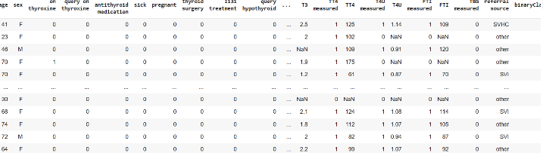**Data Cleaning:** Proper review of the dataset for missing or inconsistent values is to be done. Missing values were either deleted or imputed using the proper methods. This is significant because missing or inconsistent values might reduce the accuracy of the machine learning model.

Fig 2: Dataset view

1. **Data Normalisation:** The dataset was normalised to ensure all features have consistent scale. This helps to avoid a bias towards characteristics with higher values. Normalisation is crucial because certain characteristics have a wider range of values than others, which might impair the accuracy of the machine learning model.

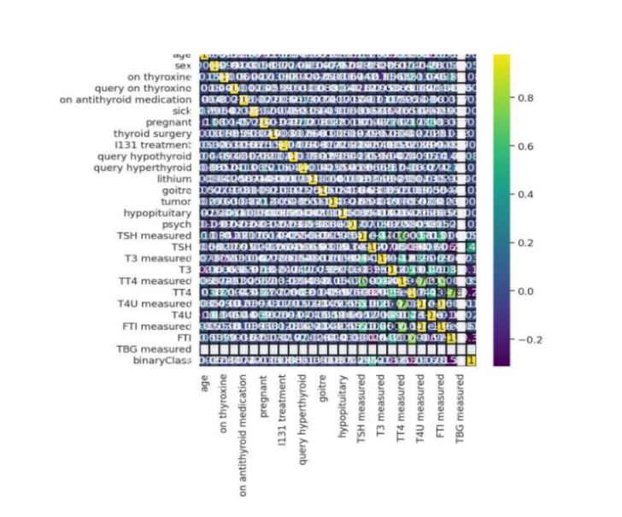

Fig 3: Data points interrelation sketch

1. **Data Splitting:** The dataset was divided into training and testing sets. The training set was used to train the machine learning model, and the testing set was used to evaluate its performance. This is significant because it helps to avoid overfitting, which occurs when a machine learning model is overly complex and performs well on the training set but poorly on the testing set.
2. ***Model Development and Architecture***

Specifically, this study focused on building a deep neural network for the purpose of predicting hypothyroid. Depending on the input data, it is using the standard deep learning approaches used in the model architecture, which comprised a thoughtfully organized configuration of layers. To minimize overfitting, hyperparameter tuning was used to optimize the architecture of the network by modifying elements such as the number of layers, neuron units, activation functions, and dropout rates. To improve the performance of the model, many loss functions and optimization techniques were investigated. Multiple levels of basic nodes made up the network's structure. The network was organized into several tiers of fundamental nodes, the first tier of which consisted of 28 nodes that handled input processing. Serving as a hidden layer, the second layer was made up of 8 nodes that processed data that had been partially processed and produced fewer output classes for layers that came after. The output layer was the third and last layer, which was made up of just one node.

Fig 4: Network architecture

**Network Organization**: The network is structured into several tiers, each composed of fundamental nodes.**First Tier**: Input Processing (Layer 1): It consists of 28 nodes. Dedicated to processing input data and taking inputs from scratch.

**Second Tier**: Hidden Layer (Layer 2): It comprises 14 nodes. It functions as a hidden layer. Processes data that has been partially processed from the first layer. Generates fewer output classes for subsequent layers.**Third Tier**: Output Layer (Layer 3): The final layer of the network. Comprised of a single node. Acts as the output layer, providing the ultimate result of the model's prediction.

1. ***Model Training and Validation***

Based on the information obtained from the dataset, its clearly observed that there are 3772 rows obtained which can be strategically divided into different number of sets for training, testing, and validation.

1. Initially the whole dataset is split into the ratio 3:1 for testing and training respectively.
2. Furthermore, the testing dataset is split in the ratio 9:1 for testing and validation respectively.

The training starts with large error and with progress in training, the losses are reduced using the optimizers and bias optimizations steps.

Validation is performed so as to cover most of the critical points where the model might have high chance of predicting a wrong value. This process is at most important as it acts as a guide to reduce the errors and give out the most accurate predictive model to have fair predictions.

The training and validation continue till a certain threshold is achieved or there is no progress in learning curve observed. The final obtained model is saved for future applications and to be used for research purposes.

To understand more about the datapoints and their correlations with each other, obtaining cross plots for the datapoints significantly.

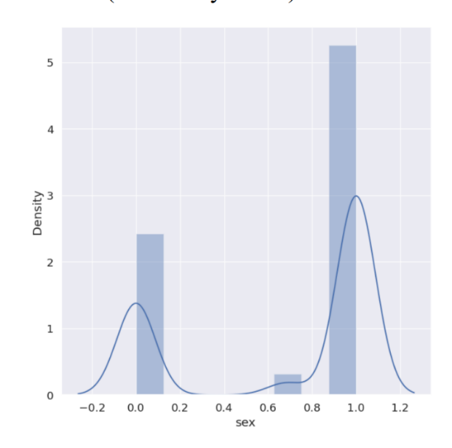

Fig 5: Comparison plot for Output density vs sex

Above figure (Fig 5) represents the gender-based outcome density, which is helpful in understanding if the gender has any significant impact on the patient’s thyroid diagnosis.

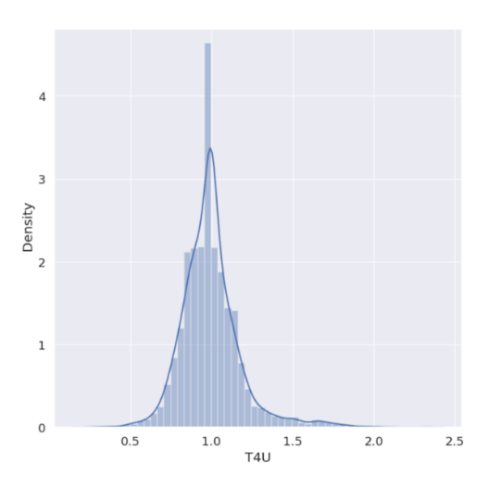

Fig 6: Density vs T4U attribute plot

Above figure (Fig 6) is a combined plot of values of T4U (Thyroxine utilization rate) with respect to the outcomes of patient’s diagnosis. With this plot we can observe that a peak positivity is obtained at 1.0.

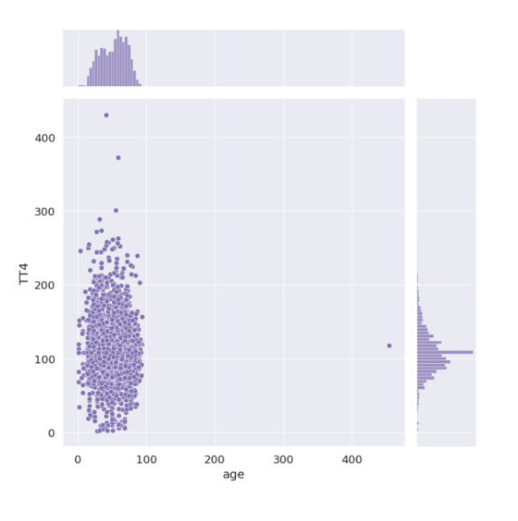

Fig 7: TT4 vs Age plot

Above figure (Fig 7) us the combined scatter plot of TT4 which is a measure of Total thyroxine present in the blood stream against the age of the patient. With this subplot, we can observe that the thyroxine values increase with age till an extent and then start decreasing. Consideration of TT4 is necessary as it is helpful in determining blood abnormalities, metabolism rate and other useful insights about patient’s thyroxine levels.

**IV. RESULTS**

1. **Metrics**

Model performance analysis is an important field of study because it helps us compare expected and predicted outcomes more effectively and provides a better knowledge of the steps involved in producing the final product. This can be accomplished using a variety of methods, such as error matrices for regression tasks and accuracy evaluations for discrete output values. Both these methods offer valuable insights into the trained model, its architecture, and its learning processes. It will also help to improve the model's prediction of hypothyroidism in patients.

1. **Precision recall**

**Precision:** How effectively a classification model's positive predictions held true is what determines how accurate it is. It shows the proportion of correctly predicted positive cases to all positive forecasts. The question "Of all the instances my model predicted as positive, how many were actually positive?" has specific responses given. In mathematical terms, it is the ratio of True positives to all of the obtained positives.

**Recall:** Recall is a metric that indicates how well a classification model recognizes and accurately captures each significant instance of a positive class. It is sometimes referred to as the true positive rate or sensitivity. It shows the proportion of all positive events that really occurred to all accurate positive forecasts. "Of all the actual positive instances, how many did my model correctly predict as positive?" is the question that arises.

In mathematical terms, it is the ratio of true positives to the total of false negatives and true positives.

1. **Accuracy**

One important indicator of how closely expected outputs match actual values is accuracy. A general assessment of the model's predictive accuracy for both positive and negative occurrences is given in this figure. Essentially, accuracy functions as the primary evaluation criterion, providing information about the model's overall efficacy in a range of prediction scenarios.

1. **F1 score:**

The F1-Score is a composite statistic that provides a comprehensive assessment of a model's overall accuracy by balancing recall and precision. A number between one and zero that represents the model's alignment of projected and anticipated values is called the F1 score. When there are no matches, the F1-Score is zero; when there is a perfect match, the score is one.

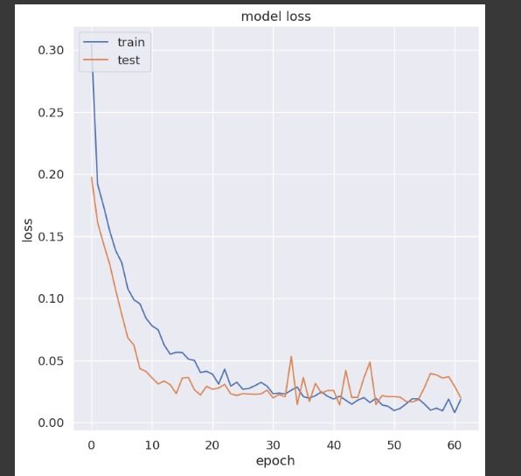

Fig 8: Model Loss vs epoch

With sophisticated training algorithms and methodologies, an insightful model is developed, which makes proper utilization of training data and significantly evaluates itself during the testing period. The end result of the research and implementation of the model can numerically be stated as the model impressively predicts hypothyroid outcomes with the given input data at an accuracy level of 99%. The training and testing losses/errors have been smartly reduced by using prebuilt optimizers and the case of overfitting has been reduced which has resulted in <1% of error/loss during the testing period.

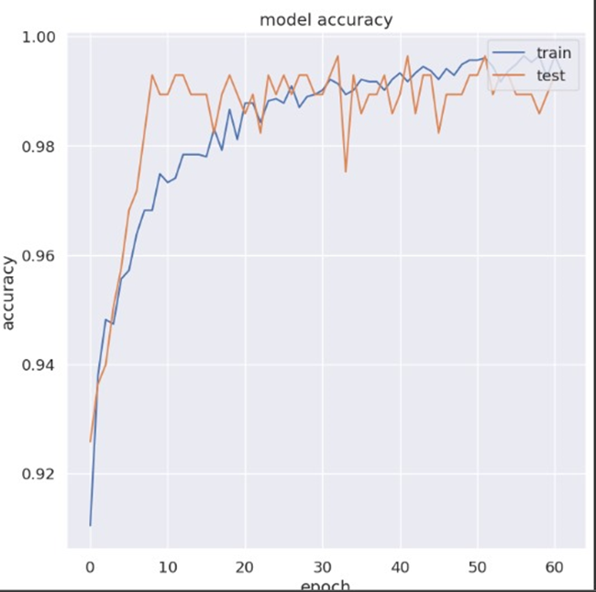

Fig 9: Model accuracy vs epoch

|  |  |
| --- | --- |
| Metrics | Values |
| Accuracy | 99 % |
| Precision | 83.78 % |
| F1 score | 89.21 % |
| Recall | 95.38 % |

Table 3: Results (Metrics & values).

**V. CONCLUSION AND FUTURE SCOPE**

This project underscores the significance of employing machine learning algorithms for thyroid health monitoring, drawing upon insights from recent literature reviews. Through the integration of advanced classification techniques, the developed model demonstrates remarkable accuracy in distinguishing between normal thyroid function and anomalies, with an accuracy rate of 99%. This result aligns with findings from previous studies, which emphasize the importance of early detection and precise diagnosis in managing thyroid disorders.

The inclusion of key features such as T4U and TSH in our model enhances prediction accuracy, mirroring the approaches adopted in successful studies by Almahshi et al. and Pal et al. Additionally, our model's robust performance reflects the potential of machine learning in thyroid health assessment, echoing the findings of Tyagi et al. and Dixit et al.

Moving forward, there are several opportunities to further enhance and expand our project. Future research could explore the integration of additional health markers and advanced machine learning techniques to improve predictive performance. Moreover, the potential incorporation of wearable devices and Electronic Health Records (EHR) could enable continuous monitoring and streamline information exchange with healthcare providers, facilitating personalized treatment plans and proactive management strategies.

Emphasizing user education and fostering collaborations with healthcare professionals and researchers will be essential for ensuring the widespread adoption and effectiveness of our approach. By leveraging insights from previous studies and continuously refining our model, we can strive to optimize thyroid health outcomes and empower individuals to proactively manage their health.

**VI. REFERENCES**

[1] M. Riajuliislam, K. Z. Rahim and A. Mahmud, "Prediction of Thyroid Disease(Hypothyroid) in Early Stage Using Feature Selection and Classification Techniques," 2021 International Conference on Information and Communication Technology for Sustainable Development (ICICT4SD), Dhaka, Bangladesh, 2021, pp. 60-64, doi: 10.1109/ICICT4SD50815.2021.9397052.

[2] H. M. Almahshi, E. A. Almasri, H. Alquran, W. A. Mustafa and A. Alkhayyat, "Hypothyroidism Prediction and Detection Using Machine Learning," 2022 5th International Conference on Engineering Technology and its Applications (IICETA), Al-Najaf,Iraq,2022,pp.159-163 doi:10.1109/IICETA54559.2022.9888736.

[3] A. Tyagi, R. Mehra and A. Saxena, "Interactive Thyroid Disease Prediction System Using Machine Learning Technique," 2018 Fifth International Conference on Parallel, Distributed and Grid Computing (PDGC), Solan, India, 2018, pp. 689-693, doi: 10.1109/PDGC.2018.8745910.

[4] R. Dixit, M. A. Tayal, S. Bedi and S. Saxena, "Thyroid Disorder Classification using Machine Learning," 2023 11th International Conference on Emerging Trends in Engineering & Technology - Signal and Information Processing (ICETET - SIP), Nagpur, India, 2023, pp. 1-5, doi: 10.1109/ICETET-SIP58143.2023.10151522.

[5] M. Pal, S. Parija and G. Panda, "Enhanced Prediction of Thyroid Disease Using Machine Learning Method," 2022 IEEE VLSI Device Circuit and System (VLSI DCS), Kolkata, India, 2022,pp.199-204, doi: 10.1109/VLSIDCS53788.2022.9811472.

[6] P. Duggal and S. Shukla, "Prediction Of Thyroid Disorders Using Advanced Machine Learning Techniques," 2020 10th International Conference on Cloud Computing, Data Science & Engineering (Confluence), Noida, India, 2020, pp. 670-675, doi: 10.1109/Confluence47617.2020.9058102

[7] D. R G, A. A. M and R. S. Kumar, "A Comparison Study on Machine Learning Approaches for Thyroid Disease Prediction," 2022 8th International Conference on Advanced Computing and Communication Systems (ICACCS), Coimbatore, India, 2022, pp. 1189-1192, doi: 10.1109/ICACCS54159.2022.9785052.

[8] K. Butchi Raju, P. Kumar Lakineni, K. S. Indrani, G. Mary Swarna Latha and K. Saikumar, "Optimized building of machine learning technique for thyroid monitoring and analysis," 2021 2nd International Conference on Smart Electronics and Communication (ICOSEC), Trichy, India, 2021.

[9] N. Ananthi et al., "Detecting six different types of Thyroid Diseases using Deep Learning approaches," 2022 International Conference on Advances in Computing, Communication and Applied Informatics (ACCAI), Chennai, India, 2022, pp. 1-8, doi: 10.1109/ACCAI53970.2022.9752581.

[10] F. Saiti, A. A. Naini, M. Aliyari Shoorehdeli and M. Teshnehlab, "Thyroid Disease Diagnosis Based on Genetic Algorithms Using PNN and SVM," 2009 3rd International Conference on Bioinformatics and Biomedical Engineering, Beijing, China, 2009

[11] M. Deepika, "A Prognostic Thyroid Disorder analysis based on Thyroid Test Measure with ECG," 2021 International Conference on Advances in Electrical, Computing, Communication and Sustainable Technologies (ICAECT), Bhilai,India,2021,pp.1-8 doi:10.1109/ICAECT49130.2021.9392450.

[12] H. H. S. Kumar, "A Novel Approach of SVM based Classification on Thyroid Disease Stage Detection," 2020 Third International Conference on Smart Systems and Inventive Technology (ICSSIT), Tirunelveli, India, 2020.

[13] A.K. Pandey, P. Pandey, and K.L. Jaiswal A DecisionTree-based algorithm for predicting cardiac disease was published in IUP J Comput. Sci. 7 (3) (2013): 43.

[14] S. Ismaeel, A. Miri, and D. Chourishi, "Using the Extreme Learning Machine (ELM) technique for heart disease diagnosis," IEEE Canada International Humanitarian Technology Conference, 2015, pp. 1–3.

[15] L. Verma, S. Srivastava, P.C. Negi. A hybrid data mining model for predicting coronary artery disease using noninvasive clinical data. J. Med. Syst. 40 (7) (2016) 1-7.

[16] R. Rajkumar, K. Anandakumar, A. Bharathi. Coronary artery disease (CAD) prediction and classification—a survey. ARPN J. Eng. Appl. Sci. 11 (9) (2006) 5749-5754.

[17] Y.T. Lo, H. Fujita, T.W. Pai, Prediction of coronary artery disease using ensemble learning and co-expressed observations, J.Mech. Med. Biol. 16 (01) (2016) 1640010.